

Laxman Dutt Degala | CS590BD | June 30, 2014

Lab 3 Assignment

**Tasks:**

1. Glassfish server to transfer the data collection.
2. HBASE CRUD operations using web services.
3. Problems faced & Things learnt
4. Create an android app to perform these functions on a *Click*

Glassfish server is installed successfully and customized web service to accommodate my data has been deployed to the server.

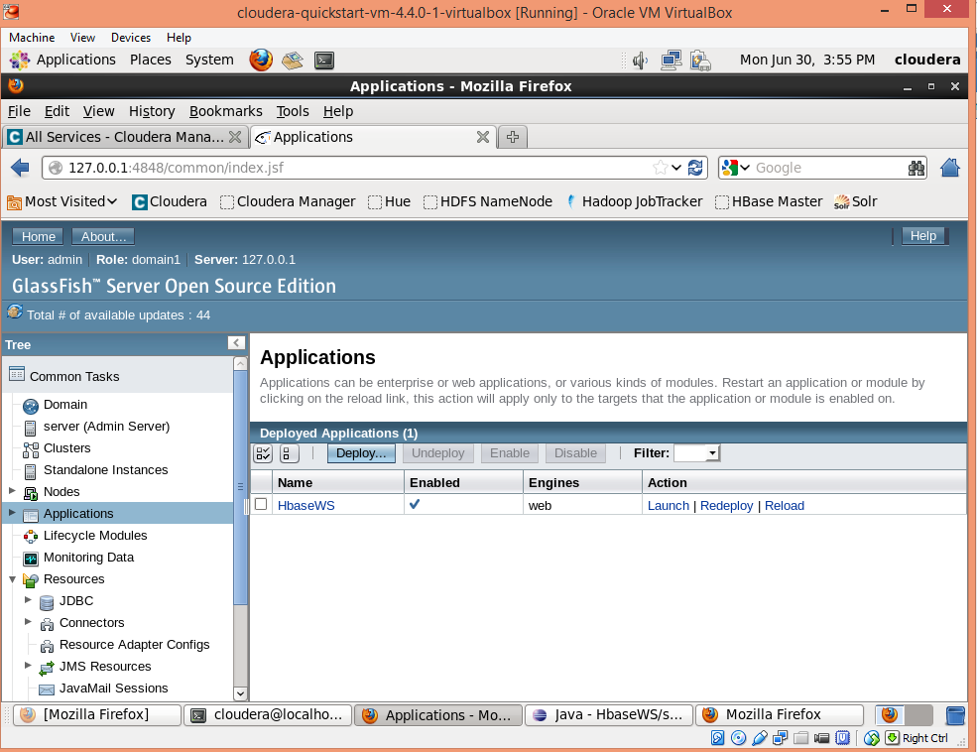

My sensor data has 5 column families. Please find attached the data file.



Have added temperature apart from the humidity which I did for lab 2.

Once the server is deployed and launched, I have created table/inserted data/retrieved data using the web service.

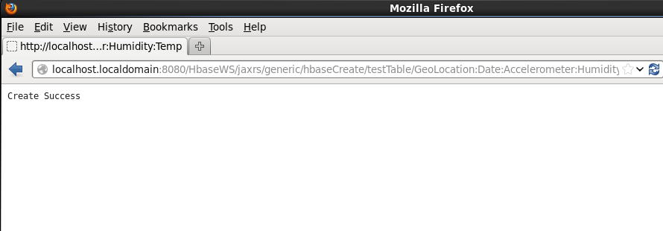

HBase UI: which has the table *Laxman_Table*

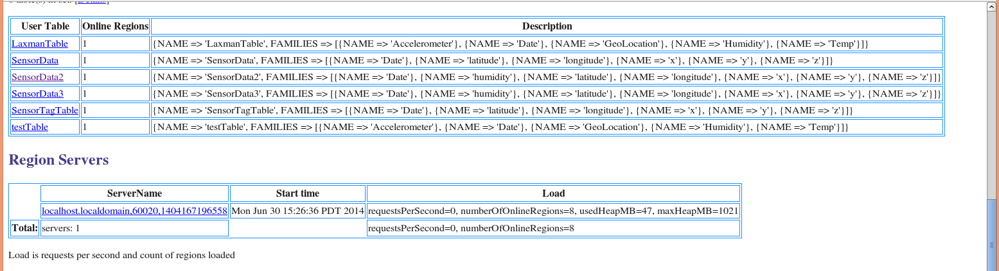

Inserted data using web service:

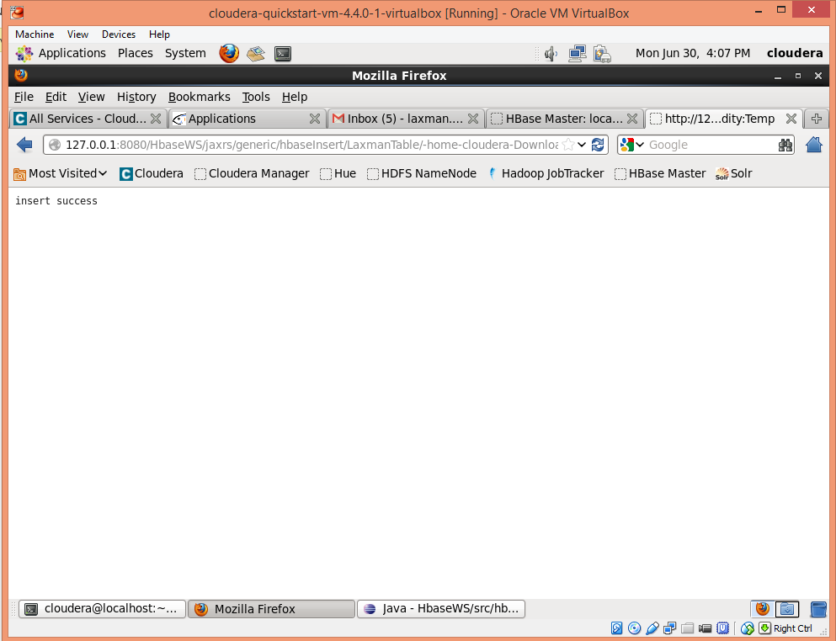

Please find attached the data that is retrieved using the web service:



Please find below the snapshot of the retrieval process done using web service.

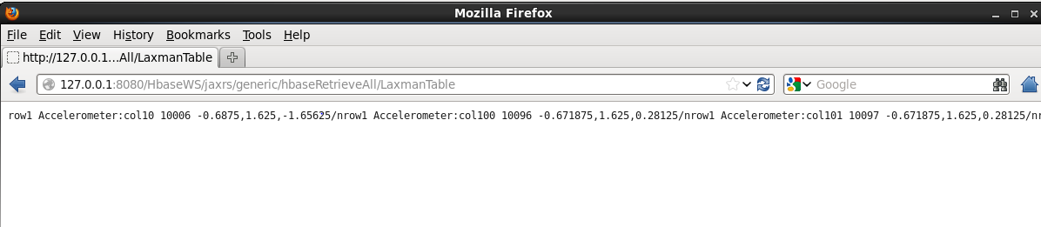

Have done the android part for uploading the data that is received from the sensor tag. I am in the process of updating the same for create and retrieve.

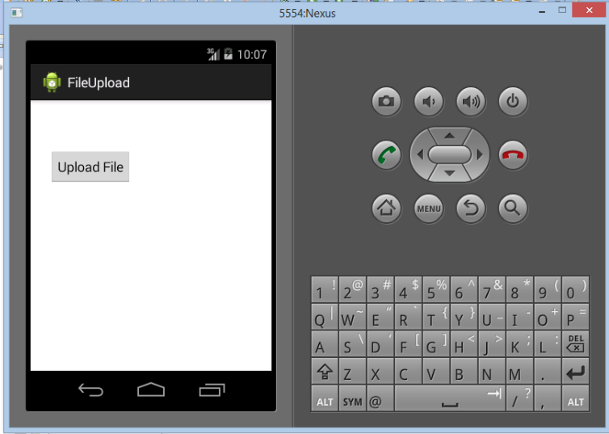

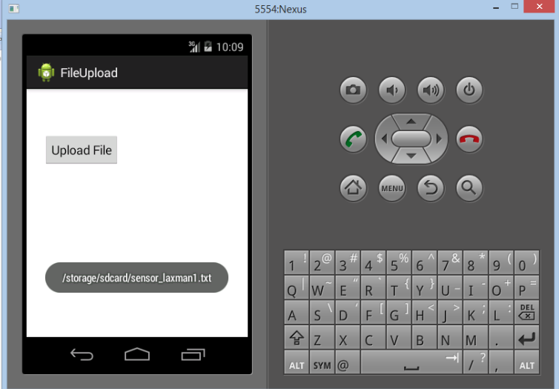

Problems faced:

1. Glassfish server didn’t start in cloudera image, as the port 8080 is used by a different process.
2. When tried killing the process, it’s again restarting.
3. After a long stint of research and discussion with Prakash, finally found the reason that *Yarn* is already using 8080 which is stopping glassfish to use the same port.
4. As we don’t use yarn in our current project, I have manually stopped the process and then restarted glassfish. It then started successfully.
5. It’s a good lesson learnt.